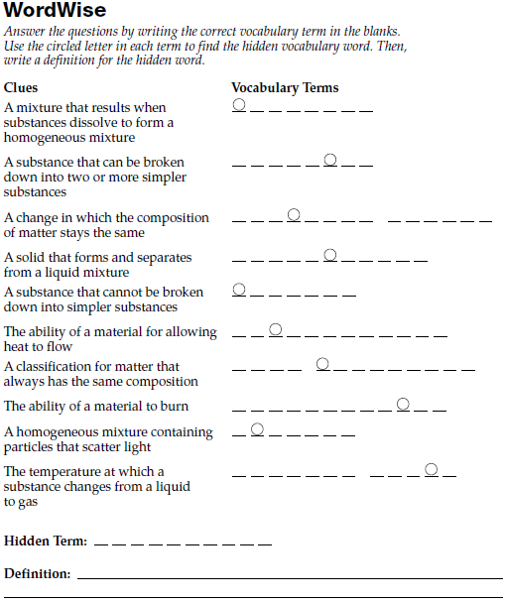Properties of Matter Unit Review. The test will cover the following topics: Matter, physical properties, chemical properties, density, states of matter and phase changes. In addition to reviewing the PowerPoints/notes and class activities, complete this review guide sampling specific content within this unit so far.

1. Complete the WordWise section below.

Use the table above to answer the next 4 questions.

1. Which substance in the table is a liquid at 105°C?
2. Which substance in the table has a melting point closest to room temperature (20°C)?
3. Which substance in the table boils at the lowest temperature?
4. Which substance has the smallest temperature range as a liquid, hydrogen or nitrogen?
5. Complete the graphic below by filling in the empty ovals (a thru d).

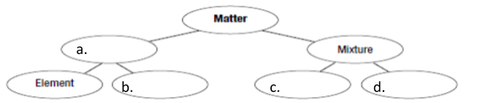

Each of the bottom ovals can be broken down more specifically. Add in ovals that would complete the diagram using the terms: atom, element, suspension, solution, and colloid.

1. Name 2 properties regarding each of the materials in the creation of a sculpture.

|  |  |  |
| --- | --- | --- |
| Wax |  |  |
| Clay |  |  |
| Metal (likely bronze) |  |  |

1. State & define 8 different physical properties.
2. What are the three indications that a chemical change has happened? Give an example for each.

Indications Example

1. Give an example of how a color change doesn’t indicate a chemical change in a substance.
2. Give an example of how the production of a gas doesn’t indicate a chemical change.
3. Density Review. For all math problems, show your work!!!
   1. At STP, water has a density of what?
   2. A material was measured to have a mass of 63mg. When its volume was measured it was 21mL. what is the substance’s density?
   3. A sample of gold has a mass of 133g with a density of 19.3 g/cm3. What is the volume of the gold sample?
   4. A graduated cylinder has a mass of 7.8g. When a solution is added, it’s new mass is 56.3g. What is the mass of the solution?
   5. The volume of solution added to the graduated cylinder is 100mL. What is the density for the solution?
4. Review all notes & PowerPoints for this unit.
5. Complete the WordWise section below for States of Matter.

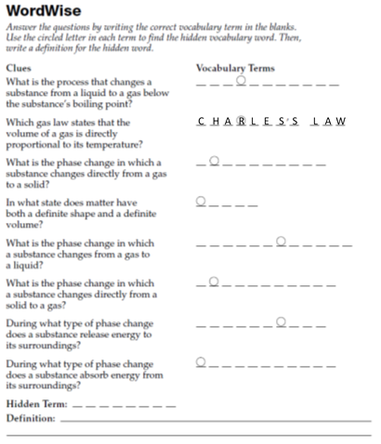

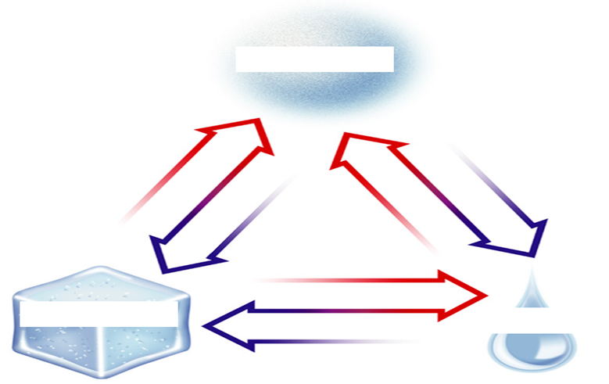

1. Complete the diagram to the right by labeling the three states of matter and all 6 arrows.
2. Which processes are…
   1. Endothermic?
   2. Exothermic?
   3. Require energy input?
   4. Give off energy to the environment?
3. 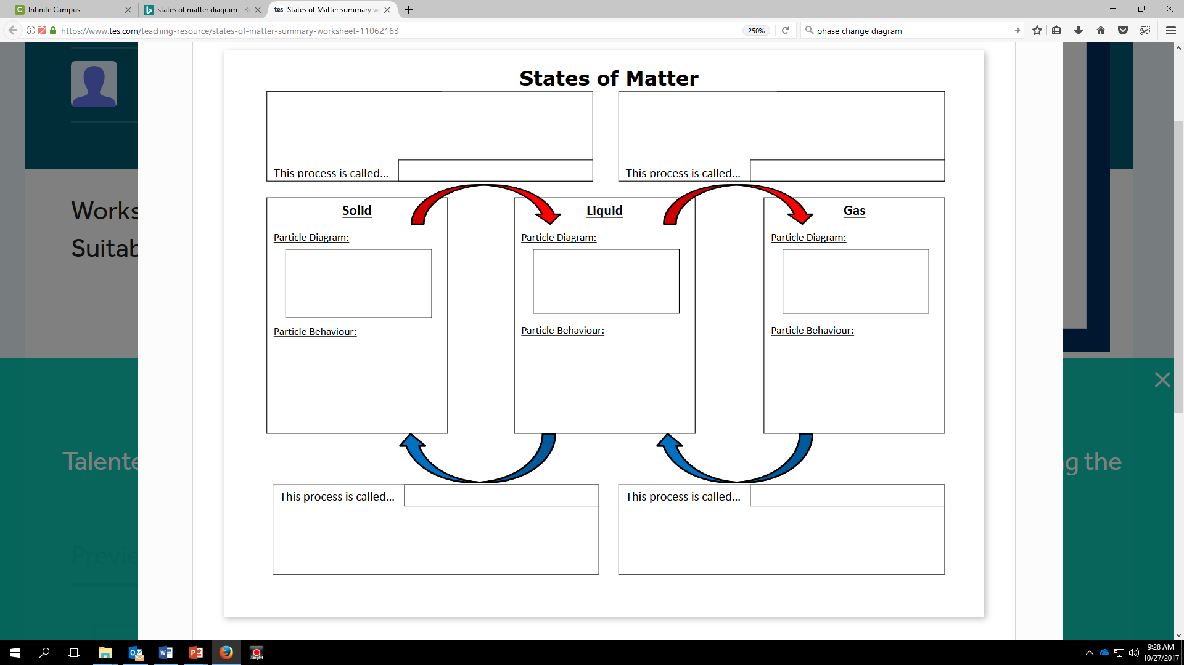Fill in the diagram using a small circle to represent a particle. First fill in the middle row of boxes with a diagram of the particles and how they relate to each other based upon the Kinetic Theory of Matter. Next, describe, using the Kinetic Theory, the behavior of the particles (how fast they move, how close they are to each other, etc.). Last, using the arrows to indicate the direction of the change between states, identify and define the phase change.

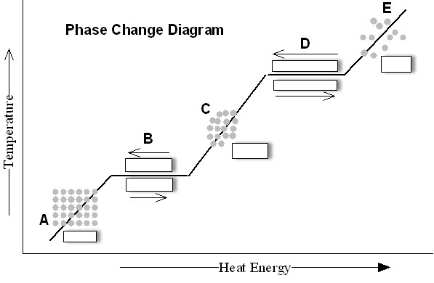

1. Complete the phase change diagram.
2. Describe what happens to the temperature at each stage:

